**ST. XAVIER’S COLLEGE**

**(Affiliated to Tribhuvan University)**

**Maitighar, Kathmandu**



**A Final Year Internship Project Report**

**On**

**UI/UX design for Digital Wallet: An online service to pay and get paid**

**At**

**Swift Technology Pvt. Ltd.**

**[CSC-452]**

**For the partial fulfillment of Bachelor’s Degree of Computer Science and Information Technology**

**Under the Supervision of**

**Er. Rajan Karmacharya**

**Lecturer**

**Department of Computer Science   
St. Xavier’s College**

**Submitted by**

**Bal Gopal Lal Shrestha (T.U. Exam Roll No. 840/067)**

**Submitted to**

**ST. XAVIER’S COLLEGE**

**Department of Computer Science**

**Affiliated to Tribhuvan University**

**June 2015**

**UI/UX design for Digital Wallet: An online service to pay and get paid**

**At**

**Swift Technology Pvt. Ltd.**

**[Course Code: CSC-452]**

A final year internship project submitted in partial fulfillment of the requirement

for the degree of Bachelor of Science in Computer Science and Information Technology awarded by Tribhuvan University

**Submitted by**

Bal Gopal Lal Shrestha (T.U. Exam Roll No. 840/067)

**Submitted to**

**ST. XAVIER’S COLLEGE**

Department of Computer Science

Affiliated to Tribhuvan University

June 2015



**CERTIFICATE OF APPROVAL**

The undersigned certify that they have read and recommended to the Department of Computer Science for acceptance, internship project report entitled **“UI/UX design for Digital Wallet – An online service to pay and get paid at Swift Technology Pvt. Ltd.”** submitted by **Bal Gopal Lal Shrestha (T.U. Exam Roll No. 840/067)** in partial fulfillment for the degree of Bachelor of Science in Computer Science & Information Technology.

…………………………..

Er. Rajan Karmacharya

Project Supervisor

Lecturer

Department of Computer Science

St. Xavier’s College

……………………………..

External Examiner

Tribhuvan University

……………………………..

Mr. Vishnu Kumar Rana

Head of Department

Department of Computer Science

St. Xavier’s College

# ACKNOWLEDGEMENT

I would like to extend my sincere gratitude to my project supervisor **Er. Rajan Karmacharya**, Lecturer, Department of Computer Science, St. Xavier’s College, for his kind and co-operative support, valuable time and guidance as well as suggestions. His useful suggestions for this whole work and co-operative behavior are sincerely acknowledged.

My forthright gratefulness goes to **Mr. Vishnu Kumar Rana**, Head of Department, Department of Computer Science, and St. Xavier’s College for whole hearted support and for giving me this opportunity to undertake this project.

I would like to express my deepest sense of gratitude and sincere thanks to our highly respected and esteemed guide **Mr. Raghu Nath Bhandari, CTO of Swift Technology Pvt. Ltd., Pani Pokhari, Kathmandu** for providing me a golden opportunity for completing my internship at their reputed organization as an Web UI/UX designer. His useful suggestions for this whole work and co-operative behavior are sincerely acknowledged.

I am also grateful to the teachers **Mr. Jitendra Manandhar, Mr. Bal Krishna Subedi, Mr. Nitin Malla, Mr. Sansar Jung Dewan, Er. Sanjay Kumar Yadav, Mr. Ganesh Yogi**, Lecturers, Department of Computer Science, St. Xavier’s College for their constant support and guidance.

At the end I would like to express our sincere thanks to all my friends and others who helped me directly or indirectly during the preparation of this report.

Bal Gopal Lal Shrestha (T.U. Exam Roll No. 840/067)

# ABSTRACT

Market generally accepts payments through Bank Cards, Internet Banking or check. The clearance procedure for check payment or Card payment is long and the Merchant has to wait for a long time to receive payment confirmation and amount. Payment through internet banking is a better option compared to card and check payment. Digital wallet is broadly a common transaction platform. Any member bank, customer, merchant can use it in the way they wish to transform their business by providing payment option for customers, mobile wallet, remittance etc. Customers can pay quickly and easily with just a few clicks through Digital Wallet Gateway.

As digital wallet is aimed to allow payments and money transfers to be made through internet, all the access channels have been secured at software, hardware and network level. Digital wallet is product of services to facilitate the customers to pay and get paid in it, so what constitute the major component of it are its customers, merchants and the financial institutions. The functions is much like a physical wallet which is a method of storing various forms of electronic money (e-cash). Digital wallets are stored on the client-side and are easily compatible with most e-commerce transactions. A server-side is the one that an organization creates for you and maintains on its servers.

TABLE OF CONTENTS

ACKNOWLEDGEMENT i

ABSTRACT ii

LIST OF FIGURES viii

LIST OF ABBREVIATION ix

LIST OF TABLES x

CHAPTER 1: INTRODUCTION 1

1.1 INTRODUCTION TO INTERNSHIP 1

1.2 BACKGROUND 2

1.3 OBJECTIVE 3

1.3.1 OBJECTIVES OF INTERNSHIP 3

1.3.2 OBJECTIVES OF PROJECT 3

1.4 BRIEF INTRODUCTION OF INDUSTRY 4

1.5 BRIEF INTRODUCTION OF ORGANIZATION 6

1.5.1 ABOUT ORGANIZATION 6

1.5.2 ORGANIZATION RATIONALE 7

1.5.2 ORGANIZATION HIERARCHY 9

1.5.6 CONTACT DETAILS 10

CHAPTER 2: ANALYSIS OF ACTIVITY DONE 11

2.1 INTERNSHIP PLACEMENT DETAILS 11

2.1.1 ORGANIZATION SELECTION 11

2.1.2 PLACEMENT 11

2.1.3 DURATION 12

2.1.4 ROLES AND RESPONSIBILITIES 12

2.2 LITERATURE REVIEW 14

2.3 SPECIFIC PROBLEM ANALYSIS 20

2.3.1 UNDERSTANDING THE PROBLEMS 20

2.3.2 DEVELOPMENT OF PROJECT GOALS 20

2.4 MANAGEMENT STRATEGY 20

2.4.1 TIME MANAGEMENT 21

2.4.2 COST MANAGEMENT 22

2.4.3 DATA COLLECTION STRATEGY 23

2.5 PROJECT SCHEDULE 24

2.5.1 TIME SCHEDULE 24

2.5.2 GANTT CHART 26

CHAPTER 3: SOLUTION DESIGN 27

3.1 PROJECT MANAGEMENT PLAN 27

3.1.1 SYSTEM ANALYSIS 27

3.1.2 SYSTEM DESIGN 30

3.1.3 ALTERNATIVE SOLUTION 35

3.2 TECHNICAL REQUIREMENT 36

3.2.1 HARDWARE REQUIREMENTS 36

3.2.2 SOFTWARE REQUIREMENTS 37

3.3.3 CROSS PLATFORM COMPATIBILITY 38

CHAPTER 4: IMPLEMENTATION STRATEGIES 39

4.1 TESTING STRATEGIES 39

4.2 HARDWARE IMPLEMENTATION 42

4.3 SOFTWARE IMPLEMENTATION 42

CHAPTER 5: RESULT ANALYSIS 43

5.1 RESULT 43

5.2 CRITICAL ANALYSIS 45

5.3 LIMITATIONS OF THE SYSTEM 48

5.4 RECOMMENDATION TO THE ORGANIZATION 49

5.5 RECOMMENDATION TO THE INTERNSHIP PROGRAM 50

CHAPTER 6: CONCLUSION 51

CHAPTER 7: REFERENCES 53

CHAPTER 8: APPENDIX 55

Appendix A: Some Relevant Screenshots 55

Appendix B: Some Important Code Functions 55

# LIST OF FIGURES

Figure 1: Organization Hierarchy 9

Figure 2: Status of Usage of Mobile Wallet 16

Figure 3: Status of service used in mobile wallet 17

Figure 4: Status of service used from Digital Wallet 18

Figure 5: Gantt chart 26

Figure 6: Report on benefits of making through Digital Wallet 28

Figure 7: Report on Customer Report using Internet 28

Figure 8: Report on Customer using smart phone 29

Figure 9: Context Diagram of Digital Wallet 31

Figure 10: DFD Level 1 of Digital Wallet 31

Figure 11: DFD Level 2 of Digital Wallet 32

Figure 12: ER-Diagram of Digital Wallet 33

Figure 13: Use Case Diagram of Digital Wallet 34

Figure 14: Sequence Diagram of Digital Wallet 35

Figure 15: Verification and Validation Model 39

Figure 16: Screen Shot of Login and Register Panel 44

Figure 17: Screen Shot of Dashboard 44

Figure 18: Screen Shot for Toup Section 55

Figure 19: Screen Shot for Toup confirmation with transaction password 55

# LIST OF ABBREVIATION

BSc. CSIT Bachelor in Science Computer Science and Information Technology

CSS Cascading Style Sheet

JS JavaScript

SQL Structured Query Language

MS SQL Microsoft Structured Query Language

CEO Chief Executive Officer

OS Operating System

SDLC Software Development Life Cycle

SRS Software Requirements Specification

UML Unified Modified Diagram

DFD Data Flow Diagram

ER Entity Relationship

NFC Near Field Communication

QR-code Quick Response Code

POS Point of Sale

SMS Short Message Service

USSD Unstructured Supplementary Services

IVR Interactive Voice Response

# LIST OF TABLES

Table 1: History of Swift Technology Pvt. Ltd. 6

Table 2: Contact Detail of Organization 10

Table 3: Duration of Internship 12

Table 4: Time Schedule 25

Table 5: Unit Test of the Project 40

# CHAPTER 1: INTRODUCTION

## 1.1 INTRODUCTION TO INTERNSHIP

The internship is six credit (minimum ten weeks/180 hour long) as a part of the course requirement included in ‘Bachelors in Science Computer Science and Information Technology’ a course affiliated by Tribhuvan University. The internship experience is expected to enable the students to assist in the resolution of complex problem. Main goal is to assist students in focusing their interests, thus aiding in their professional carrier. It gives students the opportunity to re-examine their career objectives and explore the variety of opportunities in the field of Computer Science and Information Technology. The broad objectives of internship are as follows:

* To test the interest in particular field before permanent commitment are made.
* To develop skills in the application of theory to practical work situations.
* To test the aptitude for a particular career.
* To know the value of time management and interpersonal skills.
* To develop skills and techniques directly applicable to the careers.
* To acquire in depth knowledge of the formal functional activities of a participating organization.

During author’s internship period, author was introduced to the organizational structure and the professional world. Being the student of BscCSIT, author was interested in web based application development. Therefore, to enhance knowledge in the web based application development author joined Swift Technology Pvt. Ltd. part of IME group Industries as an intern. After joining the company author was assigned for web UI-UX design. During internship period author was involved in the research and front end development of Digital Wallet.

## 1.2 BACKGROUND

The term digital wallet is broadly used to capture a variety of electronic and mobile payment services, typically through your mobile phone or online, that give you access to your accounts - just like the different cards you keep in your wallet today, but without the bulky leather and rubber bands holding it together [1]. Digital wallets can hold personal data, including your payment account numbers, shipping addresses, phone numbers, email addresses, etc. Digital wallet services may use a range of technologies, such as NFC (near-field communications) or QR (quick response) codes. Some services also offer the ability to make online payments through the use of a password rather than entering card information. You may have the option to choose which account you want to use for a given transaction, and the same password or app could work across multiple devices. In essence, a username and password gives you access to the accounts in your wallet. For online shopping, this allows you to skip the hassle of entering your name, address, and card number and expiration date. In some cases, the retailer never sees your account information, helping to protect it against being compromised. Digital wallets are generally designed to provide more convenience and control over your finances. They can even be considered safer than traditional wallets, since access to them requires passwords, passphrases or “keys.” On top of being secure, the next generation of wallets may also help you:

* Manage your payments and accounts
* Receive offers from merchants you know and trust
* Track and spend reward or loyalty points
* Store digital receipts and warranty information
* Get alerts about your account and spending

Mobile technology is changing the ways we pay, including what we think of as a wallet. Soon, along with using a card in a physical wallet, we’ll also be able to pay with a mobile phone - what is often referred to as a “digital wallet.”

Digital Wallet system developing by Swift Technology is aimed to allow payments and money transfers to be made through internet, all the access channels have been secured at software, hardware and network level. The simple principle behind it is use of encryption software at transport layer to make financial transfer between the computers. Digital wallet is product (of services to facilitate the customers to pay and get paid) in itself, so what constitutes the major component of it are its customers, merchants and the financial institutions.

## 1.3 OBJECTIVE

### 1.3.1 OBJECTIVES OF INTERNSHIP

* To develop problem solving skills
* To apply theory learned in class to an actual working situation
* To understand real world scenario
* For decision making

### 1.3.2 OBJECTIVES OF PROJECT

Digital Wallet plays an integral part in the development of digital commerce and banking. The objectives of digital wallet developed by Swift Technology are as follows:

* Utility Bill Payments: The customer can pay their utility bills such as Electricity, Water Authorities, and Internet Service Providers.
* Domestic and International Remittance: The end users can also use the Digital wallet for receiving or sending. Integration with International Money Express: Integrated International Money Express for digital remittance.
* Merchant Payment: The users will be able to make payment at department stores, restaurants, school fees, movie, airlines, bus ticket, petrol pumps, and travel agencies and so on.
* Various Topup: The customer can topup their prepaid and postpaid mobile of NTC, Ncell, UTL and Skyphone.
* Recharges: The customer can recharge their mobile of NTC, Ncell, UTL, Skyphone and even DISH Home Subscription.

## 1.4 BRIEF INTRODUCTION OF INDUSTRY

When we talk about what a digital wallet is, it’s not just a way to pay with a device. It’s taking the actual wallet in your back pocket, with all of its contents and associated behaviors and integrating it into some type of digital device [2]. Most often, that device is a mobile phone, though it doesn’t necessarily need to be. And the phone has already started to replace the wallet. From digital family pictures to an online banking app, the phone and consumer behavior is adopting the new digital wallet. Much of how we define the digital wallet is a way to pay with our phones. But it goes beyond that. Just like with a physical wallet, it’s an ecosystem of applications and experiences.

The mobile payment era is here to stay. The mobile payment market is potentially enormous and has been capturing an increasing share of the overall non-cash payments market. As a result, mobile payment technology and infrastructure are becoming a reality. It is expected that within five years 50% of smartphone users will be using their phones and mobile wallets as their preferred method for payments. Cash, cheque, and card use will continue to decline [3]. When referring to mobile payments, it is addressed a type of payment in which a consumer goes into a store and pays for a product or a service to a merchant at the Point of Sale (POS), and do so, with mobile phone, instead of using cash, a cheque or a plastic card [4]. Currently, the industry of mobile payments is starting to be developed at an initial stage. Thus, it is at this moment as the industry is exploding and the business network is getting structured and organized, when is needed to analyze the interaction between the actors involved. Today, there are four main models of mobile payments:

* Premium SMS-based payments: The premium SMS-based mobile payments consist in paying with your mobile phone by sending a premium SMS. Premium SMS refers to SMS that cost a different fee than the regular one; thus, these SMS are extra charged. Premium SMS-based mobile payments are already in use. For instance, in some European countries like Sweden premium SMS are quite extended for payments at vending machines.
* Direct mobile billing payments: Direct mobile billing payments consist in a mean of paying with the mobile phone by the actual bill linked to the mobile telecom operator. This mobile payment method is limited to expenses of small amount of money because of the actual nature of the telecom network operator actor, not being able to play a supporting credit financial role.
* Mobile web payments (by an app or by an internet browser from the mobile device): The mobile web payments model consists on paying through a payment platform established within an internet website, or an app, but both supported by internet. Therefore these mobile web payments are more an internet-based mean of payment, that an actual mobile payment. Within this mobile payments stream are highlighted enterprises like: PayPal, Square, and other relevant players.
* Contactless near Field Communication (NFC) payments: Firstly, and as a brief introduction, Near Field Communication (NFC) technology consists in a two-way, short-distance, low-power communication protocol between two devices (Nosowitz 2011). NFC-based mobile payments consist in paying at merchant’s store POS, by tapping with a NFC-enabled smartphone to the POS NFC-enabled receiver. There are different mobile payment applications models developed to work within a NFC setting.

## 1.5 BRIEF INTRODUCTION OF ORGANIZATION

### 1.5.1 ABOUT ORGANIZATION

Swift Technology Pvt. Ltd. offers a wide range of custom IT enables services and have outstanding experience in delivering custom database development, desktop, distributed and networked application design as well as development of various web components and projects. Swift Technology Pvt. Ltd. was established in 2007 as a software company for development of enterprise level solutions [5]. The development of Application and Software has been a core and continuous activity of Swift Technology since its very existence. Swift Technology relies on modern and efficient IT technology infrastructure comprising a wide spectrum of tools and platforms as well as testing environments. Swift Technology follow well-proven and professional working methodologies. It offer a wide variety of services that matches your business needs to our capabilities. Swift Technology combines technical excellence with great customer service and create new teams for each project, ensuring the best possible combination of skills and experience to meet the client's needs and deliver high end quality services.

Table 1: History of Swift Technology Pvt. Ltd.

|  |  |
| --- | --- |
| 2007 | established as an software company for development of enterprise level solution |
| 2008 | Introduce ERC (Electronic Recharge Card) for NTC (Nepal Telecommunication) pre-paid mobile users. |
| 2008 | introduced Swift ERP system package which included: HR, Payroll, Fixed Assets and Inventory Management System |
| 2009 | introduced SIM Management System for country dealer |
| 2011 | developed online balance topup system for NTC and Ncell mobile users |
| 2012 | developed BLB (Branch Less Banking) and Online Remittance System |
| 2013 | developed and deployed Core Remittance System |

### 1.5.2 ORGANIZATION RATIONALE

Swift Technology take all stages of the software development process seriously. Its primary goal is to meet all customer needs and requirements as quickly as possible – that’s why feedback, standard etc. requires us to answer any client’s question or request development status. Swift Technology believe that its high quality service provides a sound basis for a successful customer relationship, considering the testing stage of the product to be one of the most important parts of the development process and it strive to exclude any errors before the product is released.

Swift Technology does its best to provide with custom software solutions that will help to keep one step ahead competitors by continuously improving IT-enables business solutions. It use the latest software development platforms and tools to achieve this goal and also employ the latest project management techniques and software engineering principles. Also offer wide range of custom web and software solutions along with complete IT consulting services to Banks and mega Financial Institutions.

Solution that are provided by Swift Technology Pvt. Ltd. are as follows:

1. **Customer Software Development and Design:** Since its foundation, Swift Technology has delivered cost effective and high-quality software solutions for a wide range of industries and domains. These solutions have included consumer and business software development, web hosting, retail manufacturing, real estate, community services and many others.
2. **Programming services outsourcing:** Swift Technology is a custom software and support outsourcing company in its field. Some of the World's most successful Independent Software Vendors (ISVs) have relied on our unique software outsourcing experience to get their projects done on time and within budget.
3. **Consulting Services:** Swift Technology is a national full service, full life-cycle management and information technology consulting firm. We provide ICT strategy, applications, network and infrastructure solutions and enterprise resource planning (ERP) across medium to large sized institutions.
4. **Implementing Services:** Swift Technology provides full life-cycle support and configures software tools to achieve objectives. We deliver on-time, on-budget results. Working together every step of the way, your project is organized and scheduled by expert managers and delivered by trained professional.
5. **Hosting Services:** Swift Technology hosting solutions with paramount service with reliable cost and unrivalled 24x7 support to ensure total peace of mind and guaranteed customer satisfaction. SWIFT maintains its own in-house experienced technical support team to ensure that you receive reliable and friendly support at any time of day or night.

### 1.5.2 ORGANIZATION HIERARCHY

An organizational hierarchy structure is a blueprint of an organization's employees and job titles [6]. Most organizational hierarchy structures are depicted with boxes, horizontal lines and vertical lines. The boxes represent employees. Additionally, horizontal lines between boxes represent employees who hold similar titles like managers. Employees who fall vertically beneath a certain employee have lower ranks. Companies can use one or of several key organizational hierarchy structures.



Figure 1: Organization Hierarchy

### 1.5.6 CONTACT DETAILS

Table 2: Contact Detail of Organization

|  |  |
| --- | --- |
| Location: | IME Complex (6th floor), Pani-Pokhari, Kathmandu, Nepal |
| Opening Hours: | 9:00 A.M. to 6:00 P.M. |
| Tel: | +977-01-4002555 |
| Fax: | +977-01-4002777 |
| Email: | [info@swifttech.com.np](mailto:info@swifttech.com.np) |
| Website: | http://www.swifttech.com.np |

# CHAPTER 2: ANALYSIS OF ACTIVITY DONE

## 2.1 INTERNSHIP PLACEMENT DETAILS

As per the College requirement, we were supposed to choose an IT related field for our internship program. For the partial fulfilment of Bachelor’s Degree of Computer Science and Information Technology the author applied in several organization to work and learn as an intern. Among them, most of the organization would call for an interview and also some required a written tests and tasks tests. Among them all, the author was happy to be chosen by Swift Technology Pvt. Ltd. for an internship program as an UI/UX designer.

### 2.1.1 ORGANIZATION SELECTION

Selection of a proper organization is one of the important parts of internship program since it is a kind of industrial attachment project. A proper organization can give better exposure to the real work environment which is the essential objective of internship program. The priority was the selection of an organization that has sufficient resources and is well established. The author selected the Swift Technology Pvt. Ltd. an IME group of Industries that develops software for especially for IME group of Industries.

### 2.1.2 PLACEMENT

During the internship period, the author was provided with workspace at the organization, not only treated as an Intern staff but also got an opportunity to get involved with the access to the every information of the organization, organizational resources, information and equipment. The author was mostly involved in designing can client side scripting but beside that the company also gave a chance to get involved in activities like analyzing, developing and evaluating the system. During those periods, author was given task to get involved in the UI-UX design of Digital Wallet.

After three months of internship period, the author was promoted to post of trainee software engineer. Then the author was transferred to ASP.NET development team due to urgent nature of project and good prospect in application development process.

### 2.1.3 DURATION

Table 3: Duration of Internship

|  |  |
| --- | --- |
| Start Date: | October 2014 |
| Total Duration: | 8 months |
| Office Hour: | 10:00 A.M. - 6:00 P.M. |
| Lunch Hour: | 1:00 P.M. - 2:00 P.M. |
| Working Hour: | 8 Hours per Day |
| Working Days: | 6 days a week (Sunday, Monday, Tuesday, Wednesday, Thursday, Friday) - First 3 months  5 days a week (Monday, Tuesday, Wednesday, Thursday, Friday) - After 3 months |
| Position: | Intern Software Engineer - 3 months  Jr. Software Engineer - 5 months |
| Supervisor: | Pralhad Sedhai - Lead Software Engineer |

### 2.1.4 ROLES AND RESPONSIBILITIES

The UX designer uses the defined functional and content requirements for the site to develop a set of wireframe designs and flowcharts describing how users will interact with the site. Wireframes are “sketches” of page layouts indicating where functional elements and content will be placed on individual site pages, and flowcharts describe multi-step (and therefore, usually multi-page) processes users will follow to complete tasks on the website [7]. The UX designer works closely with the IA (Information Architect) in developing an overall strategic plan for building the website, and with the project manager to keep the project on target.

**Key relationships:** Information architect, UI designer, web developer, QA tester and PM

**Key deliverables:** Wireframes and flowcharts

The UI designer, also referred to as a web designer or graphic designer, is concerned with the visual presentation of the website. The UI designer may work with other graphic or print designers to coordinate the website’s appearance with related materials, or if appropriate start from scratch to develop a visual identity, including logos, fonts and color palettes. The UI designer then takes these elements, along with the UX designer wireframes, and develops a set of web page designs with full visual treatments. The UI designer may then turn these designs into web page templates using HTML and CSS, or may coordinate this task with the web developer.

**Key relationships:** UX designer, web developer and PM

**Key deliverables:** Web page designs, web page templates (HTML/CSS)

As I was appointed as UI-UX Designer in Swift Technology, my key roles and responsibility are as follows

1. Understanding customer’s brief and converting that into appealing, highly usable interfaces.
2. Engaging with the business development team and/or customer early on to seek a deeper appreciation of the customers’ business problem/goals.
3. Developing understanding of the end users of the website/application through secondary and primary research (user interviews, traffic data). Capable of generating user personas and user scenarios.
4. Preparing low fidelity prototypes of sites/features (ranging from paper-and-pencil concepts to wireframes or interactive prototypes) for internal review and brainstorming.
5. Gauging technical feasibility of the prototype.
6. Presenting high fidelity designs/mockups to the customer for review/iteration/approval.
7. Working directly with customers in an iterative/agile manner to dramatically improve the prototype in a short time.
8. Explaining design philosophy verbally and in writing.

## 2.2 LITERATURE REVIEW

Wallets have been used for thousands of years to protect and carry personal items of value. The earliest wallets or satchels were a piece of cloth tied with a piece of string which enabled a range of items such as coins to be carried to market. Humans have always been mobile and have needed a container to securely carry personal items of value while in transit. New modes of transportation have accelerated human mobility across the globe increasing this need. Wallets have evolved in shape and form but today they are still characteristically made of leather. The inventory of a wallet now includes a range of valuable items including coins, receipts, paper notes, credit cards, debit cards, driver’s license, loyalty cards, merchant cards, medical identification cards, security access cards and business cards. The information contained on many of these plastic cards enables us to identify ourselves to particular organizations such as banks and shopping stores and can enables us to transfer value using a range of payment options [8]. As humans evolve towards a continuous state of connectedness through the use of information technologies they will use electronic representations of their familiar items of value. These items have travelled with humans for thousands of years and will continue to travel with them indefinitely. To meet the needs of the digital world electronic wallets will begin to co-exist with physical wallets. Just as wallets moved from cloth to leather, they will now move from leather to the internet in order to travel the new information highways used by human society. The deployment of digital wallets has begun, and already we are seeing numerous definition and different vision for mobile wallets. Since semantics around mobile wallets is one of the current challenges in the industry. A mobile wallet is functionality on a digital device that can securely interact with digitized valuables. Digital wallet may reside on a phone, personal computer or on remote network / secure servers [9]. It may be only accessed via mobile device or personal computer, but it can also be managed and used with it. Most importantly, it is controlled by the user of the wallet.

Mobile technology is changing the ways we pay, including what we think of as a wallet. Soon, along with using a card in a physical wallet, we’ll also be able to pay with a mobile phone - what is often referred to as a “digital wallet” [10]. Mobile wallets or digital wallets which are accessed through a mobile device (e.g., mobile phone, tablet, etc....). The service allowing the wallet holder to access, manage and use mobile payment services, possibly, next to non-payment applications. As said before, this service may reside on a mobile device owned by the consumer (i.e. the holder of the wallet) or may be remotely hosted on a secured server (or a combination thereof) or on a merchant website. Typically, the so-called mobile wallet issuer provides the wallet functionalities but the usage of the mobile wallet is under the control of the consumer.

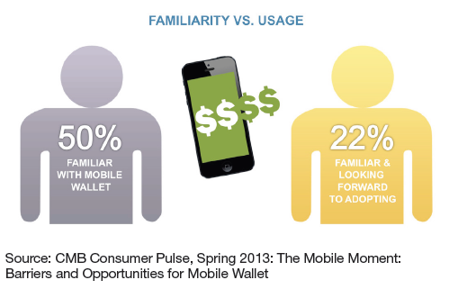[1]

Figure 2: Status of Usage of Mobile Wallet

Although different mobile wallets have been launched in the market in recent years, they are still in their early stages of development. However, a variety of services are already offered to customers. Where originally the penetration of mobile wallets was more focused on coupon deployment and loyalty management, more recently, the mobile wallet presents diverse capabilities extending well beyond these services such as the management of mobile financial services including mobile banking and payment opportunities. In fact, 65% of respondents rated the ability to make better payment choices-such as maximizing loyalty programs or minimizing interest payments as the most valued mobile wallet service [11]. Fifty-seven percent sad in managing receipts and other documentation was important. Other services that deal more with the shopping experience include:

* Real-time Incentives, 55%
* Search and shop, 47%
* Ratings and Reviews, 45%
* Place to Go, 30%
* Create and Share Wish Lists, 21%
* Sharing purchases, 10%

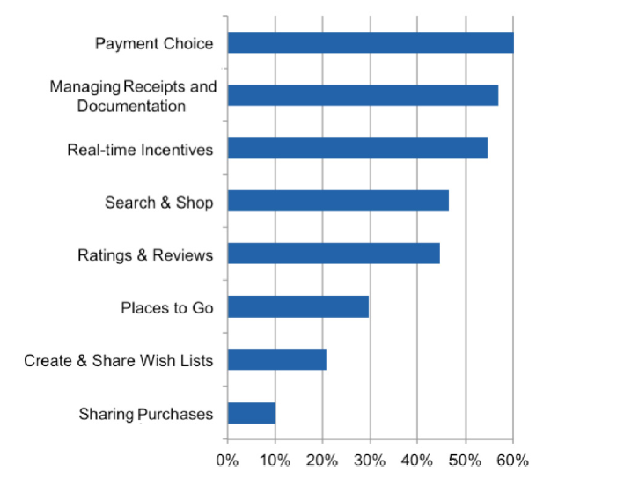[2]

Figure 3: Status of service used in mobile wallet

Whether these functions are truly available on today’s mobile wallets remains to be seen [12]. But speaking hypothetically, here’s a quick “wish list” of mobile wallet features:

* card less payments to merchants
* mobile person to person payments - sending and receiving
* electronic receipts
* coupons, special offers, loyalty programs
* geolocation
* plane or event tickets
* identification and insurance information

According to 2013 Consumer Research by Digital Research Inc survey, half of all participants have used or currently use a digital wallet system. PayPal is by far the most common digital wallet used [13].

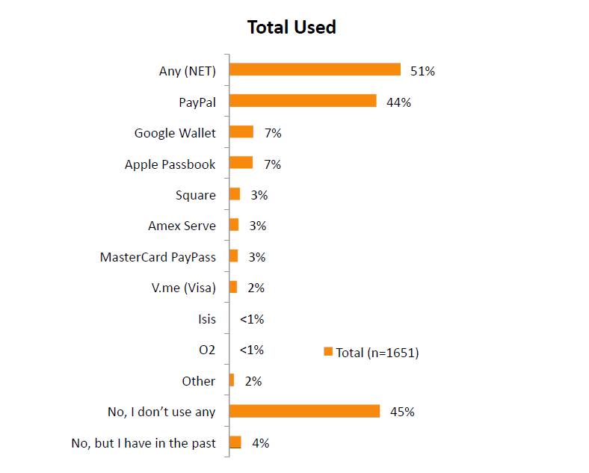[3]

Figure 4: Status of service used from Digital Wallet

A digital wallet allows users to make electronic commercial transactions swiftly and securely. It functions much like a physical wallet. A digital wallet has both a software and information component. The software provides security and encryption for personal information and for the actual transaction. Typically, digital wallets are stored on the client-side and are easily compatible with most e-commerce transactions. A server-side digital wallet, known as thin wallet, is the one that an organization creates for you and maintains on its servers. The information component is basically a database of user inputted information. This information consists of your shipping address, billing address, and other information. This concept provides a means by which customers may order products and services online without ever entering sensitive information and submitting it via wireless communication, where it is vulnerable to theft by hackers and other cyber-criminals [14]. The simplicity of financial transactions for every society is very important. In traditional methods, business will be done by exchanging physical money. Disadvantages of this method are quite evident. Besides transmission of diseases, the physical security challenges of this method are undeniable. Technology improvement and expansion of communications networks have been thriving e-commerce affairs. In order to solve these kinds of problems, various banks have developed smart card and ATM system they can withdraw money from business transactions. In this method, communication infrastructure is necessary for financial exchange. In many cases, because of communication failures, users notice the error “unable to connect to central server” on ATM display monitor. Communication infrastructure defects should not make challenge for customers and availability of banking service is a very important parameter, in this respect.

Hence, creating an independent method from infrastructure in order to exchange cash is very important. That way, the money of the customer should be kept virtually. A solution would be to replace the physical wallet with a digital wallet integrated into an existing mobile device like a cell phone. When the customer needs to perform financial transaction value of the stored software data. Each of these methods has its own advantages and disadvantages. Creating independent chip or a dedicated embedded system for e-wallet will be costly. Also, its holding is very hard for customers.

## 2.3 SPECIFIC PROBLEM ANALYSIS

### 2.3.1 UNDERSTANDING THE PROBLEMS

Finding the right tradespeople can be a real challenge. The most common complaints are around poor quality of work and a general lack of professionalism resulting in problems and issues.

### 2.3.2 DEVELOPMENT OF PROJECT GOALS

After understanding the problems it led to the conclusion that an application which is easily accessible and convenient to use should be developed. The application with following goals were developed.

* Easy: Digital Wallet is easy to implement in any system.
* Anytime, Anywhere: Customer can make payments from anywhere, at any time.
* Quick Service: It provides quick service to both parties (merchants and customers).
* Easy Collection: It enables easy collection of cash as funds are directly transferred to Merchant’s Bank Account.
* 24X7 Service: Digital wallet enables Customers and Merchants to have round the clock payment service effortlessly.

## 2.4 MANAGEMENT STRATEGY

Project management is the application of knowledge, skills and techniques to execute projects effectively and efficiently. It is the art of planning and leading software projects. It is a sub-discipline of project management in which software projects are planned, implemented, monitored and controlled through various strategies [15]. The constraints for this project, as for most projects, have been time, cost and quality. It is necessary to complete the project under these constraints and utilize the resources properly.

Management Strategy deals with the strategic decision such as formulating policies, objectives, setting goals and strategies are typically taken by board of directors, an executive committee of the CEO and top executives. They provide directions and monitor the performance of the organization on political, economic and competitive business environment. The purpose of project planning is to identify the scope of the project, estimate the work involved, and create a project schedule. Project planning begins with requirements that define the software to be developed. The project plan is then developed to describe the tasks that will lead to completion.

## 2.4.1 TIME MANAGEMENT

Time management is the act or process of planning and exercising conscious control over the amount of time spent on specific activities, especially to increase effectiveness, efficiency or productivity [16]. It is a meta-activity with the goal to maximize the overall benefit of a set of other activities within the boundary condition of a limited amount of time. Time allocated for any project is limited and development team has to work their way around that limited time. To make most out limited time, the team author was involved adopted following strategies.

**2.4.1.1 Prioritize tasks**

The team early identified various task required to complete project. Such tasks include research, database design, form design, etc. High priority tasks such as database design were given more time and resource and completed early on.

**2.4.1.2 Use Project Management Application (Red mine/ Mindomo)**

To carry out individual work at define deadline Swift technology uses two special tools Red mine and Mindomo. Red mine is a flexible project management web application. Written using the Ruby on Rails framework, it is cross-platform and cross-database. Red mine is open source and released under the terms of the [GNU General Public License V](http://www.gnu.org/licenses/old-licenses/gpl-2.0.html)2(GPL). Mindomo is simply an online mind mapping software.

**2.4.1.3 Regular Meeting**

Meeting was conducted on daily basis between development team and senior developers’ team. This allowed for efficient communication and clearly defined task for each developer each day in the project. Reasons for failure to complete daily tasks were highlighted in meeting and collective effort was made to resolve matter quickly.

### 2.4.2 COST MANAGEMENT

Budget is one of the limited factor of the project. In this particular project there are three kinds of budget involved. Managing those budgets was relatively easy for this project. Various kinds of budget of this project and its management is given below.

**2.4.2.1 Development Cost**

Development cost of this project was very minimal. Tool required for hardware was already available. Hardware required was laptops for development, and server for deployment testing. Other requirements like network was also already in place.

**2.4.2.2 Operation Cost**

For the operation of this system, a server is required. Virtual server can be used to host the application. Similarly internet is also required as this system will be accessible through internet.

**2.4.2.3 Maintenance Cost**

Maintenance cost include the maintenance of hardware and bug fix and improvement of the system. Bug fix and improvement cost will cost according to agreement between stakeholders. Similarly, maintenance won’t require extra resource. Existing IT resource of department will be enough to cover the maintenance cost.

### 2.4.3 DATA COLLECTION STRATEGY

Data collection is necessary for practically any project. Similarly, Digital Wallet project also require Data Collection. Data collection is done by mainly by interview with stakeholders of client and collecting response from questionnaire.

#### 2.4.3.1 Interview

In this data collection method, extended interviews with various stakeholders are carried out for a detail requirement analysis. The responses from stakeholders is useful for the analysis. Before taking interview make sure to create a list of questions to ask.

For the project “Digital Wallet” interview was carried out many times which clear their objectives and requirement of system they want to purpose. Main decision carried out in interview usually used to be about UI-UX design and implementation of system such a way that product can attract more user from it.

#### 2.4.3.2 Questionnaire

A questionnaire is a set of systematically structured questions used by a researcher to get needed information from respondents. Questionnaires can be handed out or sent by mail and later collected with answer to question [17]. In “Digital Wallet” project data collection by means of questionnaire was done at initial stage of requirement analysis and specification process.

Questionnaire was about queries related with feature to be integrated on system. Also it contain question about capacity of user they can get at initial stage of release of application. According to which hardware requirement were determine.

#### 2.4.3.3 Secondary Sources

Beside interview with stakeholders and collecting response from questionnaire, in-house business analyst team research on flow of other released digital wallet such as google wallet, apple passbook oxigen wallet, paytm. By taking reference from all these digital wallet feasible flow was defined.

## 2.5 PROJECT SCHEDULE

### 2.5.1 TIME SCHEDULE

Time schedule shows the total time taken to the complete the overall project and project report. It shows preliminary analysis, design, implementation testing and dissertation. This project was started at 1st January, 2015 and supposed to finished be finished till end of the April, 2015. But due to the devastating earthquake of 7.9 magnitude scale on 25th April, 2015 more than one month was assigned as risk assessment. Table 2.1 shows the time schedule of the project and project report.

Table 4: Time Schedule

|  |  |  |  |
| --- | --- | --- | --- |
| **TaskID** | **Task Description** | **Start Date** | **Finished Date** |
| 1 | **Preliminary Work** |  |  |
| 1.1 | Planning for the Intern Project | 1/1/2015 | 1/4/2015 |
| 1.2 | Analysis on the Topics | 1/4/2015 | 1/8/2015 |
| 1.3 | Meeting with Supervisor | 1/3/2015 | 2/30/2015 |
| 1.4 | Preparation of Project Proposal | 1/9/2015 | 1/11/2015 |
| 1.5 | Gantt Chart and Project Schedule | 1/13/2015 | 2/6/2015 |
| 1.6 | Approval from Supervisor | 1/16/2015 | 1/16/2015 |
| 1.7 | First Review | 1/18/2015 | 1/18/2015 |
| 2 | **Research Work** |  |  |
| 2.1 | Research on UI/UX Design | 1/19/2015 | 1/24/2015 |
| 2.2 | Research on Web-Application | 1/22/2015 | 1/28/2015 |
| 2.3 | Research on Digital Wallet | 1/20/2015 | 2/1/2015 |
| 2.4 | Research to Best flow of System | 2/2/2015 | 2/5/2015 |
| 2.5 | Second Review | 2/6/2015 | 2/6/2015 |
| 3 | **Design** |  |  |
| 3.1 | Data Flow Diagram | 2/8/2015 | 2/10/2015 |
| 3.2 | ER Diagram | 2/11/2015 | 2/12/2015 |
| 3.3 | Schema Diagram | 2/13/2015 | 2/15/2015 |
| 3.4 | Third Review | 2/16/2015 | 2/16/2015 |
| 4 | **Implementation** |  |  |
| 4.1 | Design of Client Panel | 2/18/2015 | 2/21/2015 |
| 4.2 | Design of Admin Panel | 2/22/2015 | 2/26/2015 |
| 4.3 | Database Design | 2/20/2015 | 2/31/2015 |
| 4.4 | Development of Admin Panel | 3/1/2015 | 3/20/2015 |
| 4.5 | Development of Client Panel | 3/21/2015 | 3/31/2015 |
| 4.4 | Fourth Review | 4/1/2015 | 4/1/2015 |  |
| 5 | **Testing** |  |  |
| 5.1 | Unit Testing | 4/2/2015 | 4/4/2015 |
| 5.2 | System Testing | 4/4/2015 | 4/10/2015 |
| 5.3 | Verification and Validation | 4/11/2015 | 4/25/2015 |
| 5.3 | Beta Testing | 4/26/2015 | 5/25/2015 |
| 5.4 | Fifth Review | 5/28/2015 | 5/28/2015 |
| 6 | **Dissertation** |  |  |
| 6.1 | Final Report Writing | 6/13/2015 | 6/24/2015 |
| 6.2 | Report Evaluation and Conclusion | 6/25/2015 | 6/25/2015 |
| 6.3 | Submission of Final Report Copy | 6/27/2015 | 6/27/2015 |
| 6.4 | Final Documentation Printing and Binding | 6/28/2015 | 6/29/2015 |
| 6.5 | Document Submission to College | 6/29/2015 | 6/29/2015 |
| 6.6 | Final Review | 6/30/2015 | 6/30/2015 |

### 2.5.2 GANTT CHART

Figure 5: Gantt chart

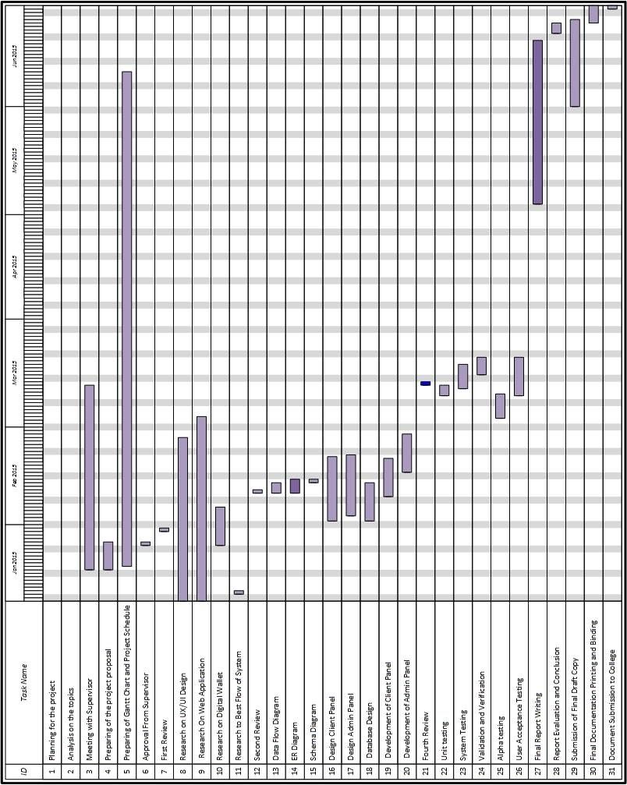

# CHAPTER 3: SOLUTION DESIGN

The chapter Solution design consists of how the project was managed in the aspects of designing and planning. It also explains about the requirements of the project from hardware used to the software used. Also it consists the topics explaining the uses and importance of different tools being used while developing an application.

## 3.1 PROJECT MANAGEMENT PLAN

Behind every successful project is a rock-solid, detailed project plan. Project planning is a discipline for stating how to complete a project within a certain timeframe, usually with defined stages, and with designated resources [16].

### 3.1.1 SYSTEM ANALYSIS

System Analysis is the process of studying an activity in order to define its goal or purpose and to discover operations and procedure for accomplishing them most efficiently [18]. System analysis is used in every field where there is a work of developing something.

#### 3.1.1.1 Feasibility Study

The proposed system first requires a system study procedure for feasibility analysis. The feasibility study helps to determine whether the system will sufficiently feasible enough to meet the objectives or not. It also helps to identify that the system will be capable of performing efficiently in long process or not.

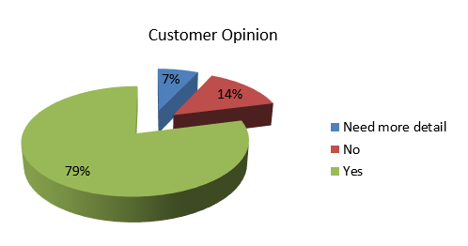

Figure 6: Report on benefits of making through Digital Wallet

To introduction “Digital Wallet” by project client different feasibility study was carried out with help of survey among their agent and customer.

From that survey, they study about “Digital Wallet” benefiting to make payments and handling cash. Result found was 7% Need more detail, 14% No and 79% Yes.

#### 3.1.1.2 Technical Feasibility

Technology is rapidly developing day by day and these development introduce new innovative application.

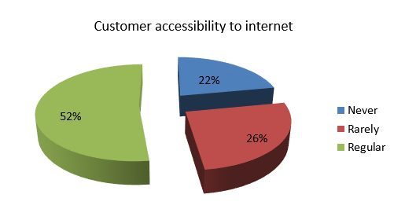

Figure 7: Report on Customer Report using Internet

According to survey customer accessibility to internet result is illustrated on pie-chart below.

22% Never, 26% Rarely, 52% Regular.

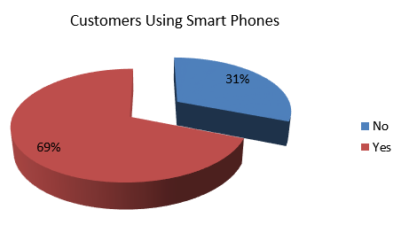

Figure 8: Report on Customer using smart phone

From the survey they also study about customer using smart phones. The result they found was 31% No and 69% Yes

#### 3.1.1.3 Economic Feasibility

In order to analyze the economic feasibility of the system, Cost/Benefit analysis is to be carried out. This tool helps to determine the benefits that can be obtained from the system by comparing them with the various costs. If the benefits are higher than the cost then the system is considered to be economically feasible to be developed. Else we can easily understand that the system is not economically feasible and certain things are to be worked out and modified in order to acquire the desired economic feasibility. The economic feasibility of the project was based on budget provided by the cost estimation made by the project manager at Swift Technology Pvt. Ltd.

#### 3.1.1.4 Legal Feasibility

Legal feasibility is to determine whether the proposed system conflicts with the legal requirements. Legal Feasibility was studied by stakeholders of project client and project managing team of Swift Technology team by going through all the legal requirements of the government of Nepal.

#### 3.1.1.5 Operational Feasibility

Operational feasibility checks if the system works with least difficulties when it is developed and installed. Operational feasibility is a measure of how well a proposed system solves the problems, and takes advantage of the opportunities identified during scope definition and how it satisfies the requirements identified in the requirements analysis phase of system development.

The user interface designed for this system is user friendly. Users can easily navigate and work around with the application. Designer team of this project has spent lot time finding out flow of system with less click and steps as possible. [16]

#### 3.1.1.1.5 Schedule Feasibility

Project client gave about 1 year for the development of the application. All the required phase for development of application will be finished within the given time frame. The analysis and design phase requires about 3 months of time. The web application development process required about 3 months. After development of web application the next phase is to develop Android, IOS and Windows phone App. For development of mobile based application it is expected to complete within 3 months. And finally for testing of application it is estimated 3 months of time period. The system is expected to be ready in full phase and ready to launch after 1 years of research and development process.

### 3.1.2 SYSTEM DESIGN

#### 3.1.2.1 Context Diagram

The context diagram is a diagram that represents the actors outside the system that could interact with the system [19]. It consists of entities (labeled boxes, one in the center representing the system and around it, multiple boxes for each external actor) and relationships (labeled lines between the entities and system).



Figure 9: Context Diagram of Digital Wallet

Figure 9 shows the context diagram of “Digital Wallet”. The main processing system is shown in the circle which is located at the center. The entity that interacts with the system are shown in the rectangle box i.e. Customer, Merchant, Admin and Bank.

#### 3.1.2.2 DFD (Level 1, Level 2 and for major processes)

The data flow diagram (DFD) for the Cooperative Online Information System is a graphical representation of the "flow" of data through the system, modeling its process aspects. DFD is a preliminary step used to create an overview of the system which can later be elaborated [20]. DFD is used for the visualization of data processing and structured design.



Figure 10: DFD Level 1 of Digital Wallet

Figure 10 is DFD level 2 expanding form of context diagram to DFD level 1 for General Public. Here, general public login to the process 1.0 Digital Wallet. Then select service of recharge and payment is done to merchant.



Figure 11: DFD Level 2 of Digital Wallet

Figure 11 shows expanded form of DFD level 1. Here, customer select service of recharge and select operator and merchant get payment for recharge.

#### 3.1.2.3 ER Diagram

ER Diagram is a detailed, logical representation of the data for an organization or for a business area [20]. It is expressed in terms of entities in the business environment, the relationships or associations among those entities and the attributes or properties of both entities and their relationships.

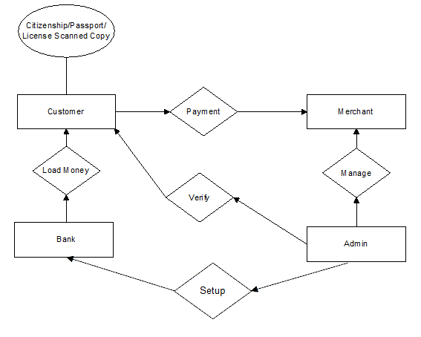

Figure 12: ER-Diagram of Digital Wallet

Figure 12 shows the ER- Diagram. There are mainly four entity Customer, Merchant, Bank, and Admin. Customer load money from Bank and perform payment to merchant which is managed by Admin. Admin also setup Partner Bank.

#### 3.1.2.4 Use Case Diagram

Use case diagram consists of use cases and actors and shows the interaction between them [20]. The key points are:

* The main purpose is to show the interaction between the use cases and the actor.
* To represent the system requirement from user’s perspective.
* The use cases are the functions that are to be performed in the module.
* An actor could be the end-user of the system or an external system.



Figure 13: Use Case Diagram of Digital Wallet

Figure 13 shows the Use case diagram of the system. Here the actors are Customer, Merchant, Admin, and Bank. Customer interact with bank to load money and also interact with merchant for payment. Admin Setup bank and manage all actives.

#### 3.1.2.6 System Sequence Diagram

The Sequence Diagram models the collaboration of objects based on a time sequence. It shows how the objects interact with others in a particular scenario of a use case [21].

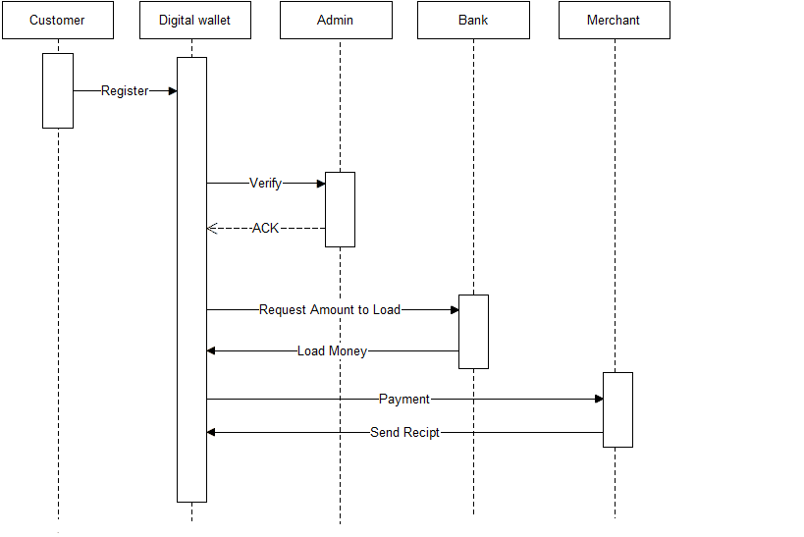

Figure 14: Sequence Diagram of Digital Wallet

Figure 14 is sequence diagram, first customer register with digital wallet system then registration is verified by admin and confirms verified customer. Then customer Load money from bank. From that loaded money payment is done to merchant.

### 3.1.3 ALTERNATIVE SOLUTION

The degree of the success in developing the new proposed application according to the customer’s requirement and criteria is determined by the proper selection of the best alternatives. Such chosen best alternative should be properly implemented using the most suitable methods and procedures. Other than the web based application and mobile application, the system can be developed for non-web and smart phone users with help of SMS, USSD and IVR based system.

## 3.2 TECHNICAL REQUIREMENT

A technical requirement pertains to the technical aspects that your system must fulfill, such as performance-related issues, reliability issues, and availability issues [22].

### 3.2.1 HARDWARE REQUIREMENTS

#### 3.2.1.1 Web Server Hardware Requirement

IIS 8.0 webserver is required. Hardware requirement vary widely depending on the traffic to your web system. The complexity of its logic (i.e. ASP.NET) and its size (i.e.MS SQL Server 2012).

**CPU and Memory:** As for any web application you should size your server based on the traffic on the site. But estimated configuration of CPU is 2x Intel XEON Six Core Processor and memory of 64 GB PC3-10600 CL9 ECC DDR3 13333 MHz

**Disk:** The amount of disk space required for the database will vary depending on the RDBMS and the volume of data, the main driving factor being the expected number and size of attachments. Estimated storage is 4X 600GB 10Krpm SAS Hot Swappable (RAID 10).

#### 3.2.1.2 Web Client Hardware Requirement

**CPU:** 2 GHz processor

**RAM:** 256 MB

**Disk:** Disk space depending upon which web browser is installed.

#### 3.2.1.3 Mobile Hardware Requirement

Mobile application can only be fully functional when application is connected to the internet. The internet can be either Wi-Fi or 3G.

**Processor:** 1GHz

**RAM:** 256 MB

**Disk:** 2 MB space Memory space

### 3.2.2 SOFTWARE REQUIREMENTS

#### 3.2.2.1 Web Server Software Requirement

**Operating System:** Microsoft Server 2012 R2

**Platform: .**NET Framework 4.0

**Database:** Microsoft SQL SERVER 2012

#### 3.2.2.1 Web Client Software Requirement

**Operating System:** Windows XP or Linux or above version

**Browser Requirements**

Microsoft Internet Explorer 6.0 or higher (7.0 or higher recommended).

Opera 7.0 or higher (9.5 or higher recommended).

Apple Safari 1.0 or higher (3.0 or higher recommended).

Mozilla Firefox 3.0 or higher (3.5 or higher recommended).

**Browser Settings Requirements**

JavaScript and cookies should be enabled for full functionality.

3.2.2.3 Mobile Software Requirement

**Operating system:** Android, IOS, Windows

**Database:** MySQL, SQLITE

### 3.3.3 CROSS PLATFORM COMPATIBILITY

Cross Platform Compatibility refers to ability to run on multiple types of computer systems. Since the application was developed with bootstrap framework thus the application is supportive in all device screen size from desktop, laptop, tablets, mobile phone etc [23].

# CHAPTER 4: IMPLEMENTATION STRATEGIES

## 4.1 TESTING STRATEGIES

Testing is an investigation conducted to provide stakeholders with information about the quality of the product or service under test. Test techniques include, but are not limited to, the process of executing a program or application with the intent of finding software bugs (errors or other defects).

Strategies of testing for this project is Validating and Verifying process. Validating and Verifying process includes following steps

* + Meets the requirements that guided its design and development.
  + Works as expected.
  + Can be implemented with the same characteristics.
  + Satisfies the needs of stakeholders.

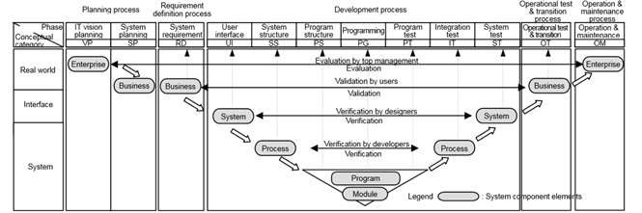

Figure 15: Verification and Validation Model

As there was no automated testing software available all the tests were performed manually. Valid and invalid data are entered manually and verified manually.

Software testing is more than just debugging. The purpose of testing can be quality assurance, verification and validation or reliability estimation. Our software testing methods is applied in following distinct phases:

Unit testing, sometimes called module testing is an automated technique whereby each module is tested alone in an attempt to discover any errors that may exist in the module code. It is one of the dynamic testing types.

Table 5: Unit Test of the Project

|  |  |  |  |
| --- | --- | --- | --- |
| No. | Test Objectives | Test Condition | Expected Result |
| 1. | Login to the system | Here the Username, Password is authenticated | If login is successful it creates session and redirects to initializes user account |
| 2. | Logout from the system | Here the system is exit from user account | Logout destroy the session and redirects to the home page |
| 3. | Insert the data record from specific module in system | Enables user to insert data using different forms | If the user has inserted in the form then it is successfully saved in the database |
| 4. | Display information from search module | Check whether the available information are displayed or not | When the member enters the information, the information is displayed with different view levels |
| 5. | Inserting sql injection attacks | Inserting malicious sql query that are later passed to a database for execution. | Inserting sql injection query in the form or query string will not be executed |

**4.1.2 Form Validation Testing**

The form validation is a process of testing and ensuring that the user has entered required and properly formatted information through the web form and it also guide the user to fill proper and valid information. Here test data is identified and tested, the expected output and actual result is analyzed whether there exist problems or failures or not.

**4.1.3 Browser Compatibility Testing**

The developed system was tested on different available browser. First of all we developed our whole system in Mozilla Firefox and later on we checked on different browser like Google Chrome, Internet Explorer, Safari, Opera, etc.

There is still some bug on lower version of Internet Explorer because it doesn’t support some latest HTML5 and CSS3 syntax. If we upgrade to latest version it will be bug free.

**4.1.4 System Testing**

System testing is the testing of behavior of a complete and fully integrated software product based on the software requirements specification (SRS) document. Integration of different modules comprises a system. Once all the required modules were developed and integrated, the system as a whole was tested to ensure that the system is functioning correctly and efficiently. This test is very helpful to determine the problems and bugs that have been escaped during the integration testing. This testing was done to ensure that the system meets the user requirements.

At this testing the complete system was tested to check for errors. The system was compiled and run to check if errors exist. The errors that appeared were either resolved or handled properly.

**4.1.5 Beta Testing:**

For 4 months system has to be tested among limited set of users to identify any issues with the system and rectify it.

## 4.2 HARDWARE IMPLEMENTATION

The project “Digital Wallet” was built on ASP.NET platform and database server used was MS SQL Server 2012. Thus the server host for application was IIS 8.0 with Window Server 2012 R2 with configuration of 2xIntel XEON Six Core Processor CPU, 64 GB PC3-10600 CL9 ECC DDR3 13333 MHz RAM and storage of 4X600 GB 10Krpm SAS Hot Swappable (RAID 10).

## 4.3 SOFTWARE IMPLEMENTATION

Since development platform of “Digital Wallet” was ASP.NET, it requires .NET Framework 4.0 with Database software Microsoft SQL Server 2012.

# CHAPTER 5: RESULT ANALYSIS

The Digital Wallet is online payment system. Digital wallet are stored on the client-side and are easily compatible with most e-commerce transactions. A server-side is the one that an organization creates for you and maintains on its servers.

## 5.1 RESULT

The developed system can perform tasks mention as below:

* Utility Bill Payments: The customer can pay their utility bills such as Electricity, Water Authorities, and Internet Service Providers.
* Domestic and International Remittance: The end users can also use the Digital wallet for receiving or sending. Integration with International Money Express: Integrated International Money Express for digital remittance.
* Merchant Payment: The users will be able to make payment at department stores, restaurants, school fees, movie, airlines, bus ticket, petrol pumps, and travel agencies and so on.
* Various Topup: The customer can topup their prepaid and postpaid mobile of NTC, Ncell, UTL and Skyphone.
* Recharges: The customer can recharge their mobile of NTC, Ncell, UTL, Skyphone and even DISH Home Subscription.

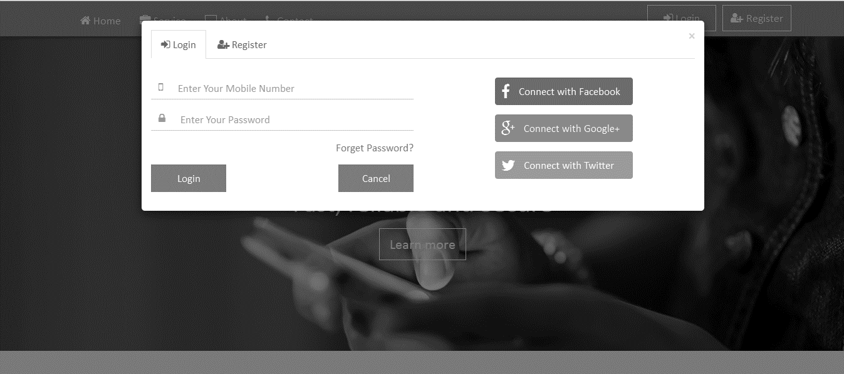

Figure 16: Screen Shot of Login and Register Panel

Figure 16 show Login and Register Panel from where users login or create credential of Digital Wallet i.e. register.

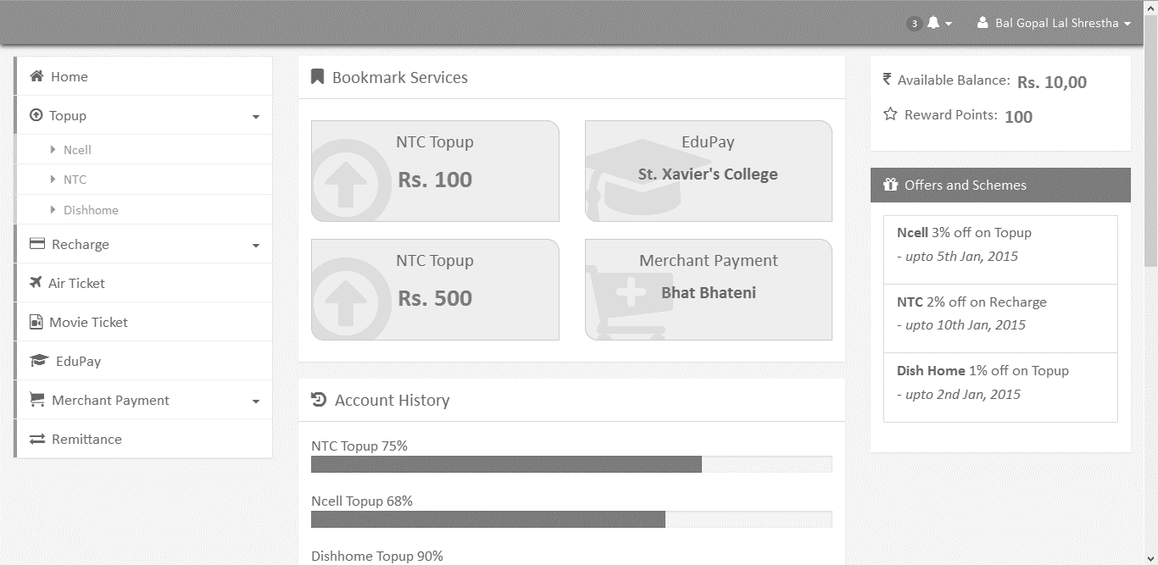

Figure 17: Screen Shot of Dashboard

Figure 17 show Dashboard Screen, showing all service list at right side of dashboard page. From that link user can navigate to service that they want to use.

## 5.2 CRITICAL ANALYSIS

Digital payment era is here to stay. The digital payments market is potentially enormous and has been capturing an increasing over cash payments market. As a result, digital payment technology and infrastructure are becoming a reality. Cash, checks and cards use will continue to decline due to time taking process of payment. With this system, customers can pay quickly and easily with just a few clicks through Digital Wallet Gateway. A digital wallet allows users to make electronic commercial transactions swiftly and securely. It functions much like a physical wallet. This concept provides a means by which customers may perform payment through online without even entering sensitive information and submitting it via wireless communication.

This Digital Wallet had successfully fulfilled all the scope objectives mentioned above. The application fits perfectly for the Utility Bill Payment (Electricity, Water Authorities Landline and various Internet Service Providers), Merchant Payment (Department stores, restaurants, school fees, movie ticket, airlines ticket, bus ticket, petrol pumps, and travel agencies), recharge (NTC, NCell, UTL, Skyphone even DISH Home Subscription) and various Topup (NTC, NCell, UTL and Skyphone). By means of this application client will get facilities of various features such as easy implementation, anytime, anywhere service i.e. 24X7 service, quick service for both merchants and customers, easy collection of cash and finally secure transaction that ensure for scams and fraudulent transactions with immediate authorization.

With covering all mention scope and objectives, this digital wallet could be enhanced more. Digital wallet is web based application with feature of mobile and tablet view compatibility and mobile application for Android and IOS. Thus it binds only customer using latest technology but for those customer who is not used to with latest technology it becomes difficult get facilities of it. For this demerits we can enhance with implementation of SMS based system, USSD (Unstructured Supplementary Services) and IVR (Interactive Voice Response). Digital wallet only allow payment when it is loaded by required amount to be paid. It is essential for user to have bank account of one partner banks to load amount on Digital wallet. Viewing user for rural areas, it will be difficult for them to have bank account that leads them away from Digital wallet service. To overcome this, agent based load money can be implemented. Agent based system can be useful for customer who are illiterate and can’t use Digital wallet. Agent will assist illiterate customer with digital wallet service.

Bootstrap CSS frameworks is used for user interface design. Designers need a solid foundation, with Bootstrap framework gives almost everything a typical web application would require and is flexible enough for customization. Bootstrap’s CSS files are also provided in LESS which makes it very easy to customize if you already use LESS for CSS preprocessing. Undoubtedly one of the biggest advantages of using Bootstrap is the speed of development. Rather than coding from scratch, Bootstrap enables you to utilize readymade blocks of code to help you get started. Combine that with cross-browser compatibility and CSS-Less functionality, many hours of coding can be saved. Mobile devices continue to grow in popularity year after year. The need to have a responsive website is becoming increasingly important. Using Bootstrap’s readymade classes, you can specify how many spots in the grid system you want each column to occupy. Then you can specify at which point you want your columns to stack horizontally rather than vertically to display properly on mobile devices. Bootstrap can be tailor made according to the specifications of your project. Developers have the ability to pick and choose the features that are needed and the rest can be tossed.

Unfortunately frameworks also come with some massive disadvantages. Framework is not your code. With that knowledge comes the fact that you may not understand why things are working (or not working) as they are. Granted, not everyone that puts up a website needs to know exactly how it's working, but any developer with a sense of curiosity will want to dive deeper to try and figure things out. If you’re a web developer who builds custom sites for clients, a framework is not the way to go. You’re going to need to know your code and when you go with a framework, you’re leaving a lot of decisions to somebody else. When it comes to updating a framework, you could be left in lose-lose situation. If you don’t update to the latest version, you could fall out of step with current web standards, or if you update it, you run the risk of breaking things. When you're using someone else's code, you leave it up to their discretion as to what standards and methods to use for the next release. Web best practices change constantly, and it's your job as a developer to stay up-to-date. You could opt to ignore future framework updates altogether and stick with what you've got, but then you run the risk of falling behind future web methods and standards. For example, changes made to Bootstrap 3 included dropping support for IE7, and going mobile first (using min-width vs using max-width on media queries). These are HUGE changes that could break a site updated from 2.x. No one knows what’s next. But more importantly, you have no control over it.

The development is carried out in ASP.NET platform. The main reason for carrying out the project in ASP.NET is because of its high security features. ASP.NET has some methods of its own that make it better and secure. SQL injection can be prevented using the SqlParameters that allow us to minimize the injection. ASP.NET has a security namespace that defines all the methods that a company can use to protect its system. You can create Roles, user Membership class, etc. In ASP.NET, applications is developed using C#, that can create simple classes of the data and then work with the data using those classes inside your application without having to worry about any side-code. ADO.NET is part of ASP.NET (.NET Framework) that lets you work with data. ASP.NET itself is a basic implementation of the .NET Framework over the Internet services and the websites. You can create as much projects as you want, and run on the same server. Almost all of the major companies are running on ASP.NET because it lets you gain control of it yourself. C# let you create your own modules. Use some library tools from MSDN (Microsoft Developer Network) and create your own web applications. ASP.NET is vast enough for you to develop any sort of application, and you don’t even have to worry about the platform, thanks to the Mono Project, you can now write the ASP.NET applications on the non-Windows OS too. Further, Visual Studio Express that is for free lets you develop ASP.NET application in better manner by providing competitive tools for the developers to test and develop their application.

Complain of ASP.NET are that they are expensive and their upkeep is resource intensive. Most ASP.NET applications run on IIS. Additionally, ASP.NET uses far more web servers or a greater number of them. Finally, Windows and IIS have a documented history of bugs and vulnerabilities in the programs have been prone to exploitation in the past.

For the project Digital Wallet database is maintained on Microsoft SQL Server. Microsoft SQL Server comes with lots of excellent tools like SQL Server Profiler, SQL Server Management Studio, BI tools and database tuning adviser all will save you a lot of time in development and troubleshooting. SQL server has been evolving rapidly in multiple technologies, in SQL Server 2012 they introduced column based indexing which in a way is introduction to NoSQL in SQL server. SQL Server 2014 has come with memory optimized table. T-SQL remains consistent across new versions of SQL server and best XML support.

There also exist some Cons of using Microsoft SQL server database. With Microsoft SQL server you have to be in Microsoft’s ecosystem to use SQL server. Meaning buying their server products which would again be costly. For any new feature, Microsoft generally ships updates in 2 years cycle. Due to now rapid development from Microsoft to get new and latest features you again have to make big investment.

## 5.3 LIMITATIONS OF THE SYSTEM

The system developed during the intern period has some limitation and room for improvements. Although the system is developed as per the specification given by project client the author felt there are few areas where system had its limitations. These limitations are summarized in following points:

1. This application is only applicable for user having internet access or smart phone. Thus, it leaves behind user who couldn’t access to internet and doesn’t have smart phone.
2. Entire application is built on English language. The user who have only knowledge about Nepali language will be left behind.
3. User can only load money in Digital wallet if he has account on partner bank of Digital wallet. Users without having bank account can’t get service from digital wallet.
4. Compare to online payment merchant, site payment merchant is less. If this project can increase merchant for site payment through digital wallet, the service will be more effective and efficient.

## 5.4 RECOMMENDATION TO THE ORGANIZATION

Internship at Swift Technologies Pvt. Ltd. was a great opportunity for the author to build professional career as the staff of the organization provided much needed support and help. Still, the author would like to make few recommendations to the organization based on its limitations.

1. Organization can increase number of staffs who can work independently in different departments. This way staffs can work without much pressure and distractions.
2. Core management team would be beneficial for the organization. There is project manager but no organizational manager. It would be better to hire someone with good organizational management skill.
3. It would be beneficial for all the staffs if they were given more responsibility in development department. This will remove pressure from principal developer and help other developers increase their skill.
4. Various motivational activities should be carried out to keep morale of all the staffs in good shape.

## 5.5 RECOMMENDATION TO THE INTERNSHIP PROGRAM

Internship is great concept which provides students to test their knowledge and skills in real world. It gives students to get acquainted with real world of profession and gives chance to be prepared for real world after graduation rather than being clean slate. Nevertheless, there are numerous limitation of this program which this author found. Hence, author like to recommend following for improvement of internship program and increasing its effectiveness.

1. It would be better if organizations treat interns as interns not professional with tons of experience. Some organizations take advantages of intern and make to pointless tasks that will not give them any additional knowledge.
2. Some companies take advantage of interns and make then do the most menial, tedious tasks that will barely enhance their skills. Many interns come out from the experience feeling frustrated and as though they haven’t gained any valuable skills. There should be some mechanisms to prevent such occurrences.
3. It would be better if all the interns are given at least minimal financial benefit so that both intern and organization are happy.

Interns are bound by confidentiality of the organization. So, it is difficult for them to present their work in their report for university. It would be better if either organization or the university made some consideration for students on this matter.

# CHAPTER 6: CONCLUSION

With Internship opportunity, the author has gained much more insight into the professional environment in IT industry and helped to develop vital skills that go beyond what regular classed and courses cover. During these nine months of program, the author got chance to work in Digital Wallet System. This gave author to learn new knowledge and interact and deal with clients. During the development, author got the practical view of software development process and learn vital knowledge from it.

Although author didn’t master all of these technology, author got to learn enough to get started. Some of learnt tools and technology are CSS, LESS, SAS, JavaScript, Jquery, Angular JS, ASP.NET and MYSQL Server.

The project Digital Wallet will revolutionize how people spend their money. People will experience much more simple financial transaction through their smart phones and personal computer. The Digital Wallet is aimed to allow payments and money transfer to be made through internet. Hence, Digital Wallet is product (of service to facilitate the customers to pay and get paid) in itself, so what constitute the major component of it are its customer, merchants and the financial institutions.

Although, the “Digital Wallet” purposed has covered all objectives derived on research and planning phase. But still it requires enhancement viewing users mostly from rural areas. Digital wallet is web based application with feature of mobile and tablet view compatibility and mobile application for Android and IOS. Thus it binds only customer using latest technology but for those customer who is not used to with latest technology it becomes difficult get facilities of it. For this demerits we can enhance with implementation of SMS based system, USSD (Unstructured Supplementary Services) and IVR (Interactive Voice Response). Digital wallet only allow payment when it is loaded by required amount to be paid. It is essential for user to have bank account of one partner banks to load amount on Digital wallet. Viewing user for rural areas, it will be difficult for them to have bank account that leads them away from Digital wallet service. To overcome this, agent based load money can be implemented. Agent based system can be useful for customer who are illiterate and can’t use Digital wallet. Agent will assist illiterate customer with digital wallet service.

# **CHAPTER 7: REFERENCES**

|  |  |
| --- | --- |
| [1] | "Digital Wallet Security," 22nd June 2015. [Online]. Available: http://www.visa.com/security. |
| [2] | C. White, "Thin is in: The future of digital wallet," 2011. |
| [3] | Carlishle & Gallagher Consulting Group, "Mobile Wallet Reality Check: How will you stay top of wallet". |
| [4] | M. S. Garvin, "Network constellations for mobile payments - Influence of the leading partner on NFC-based mobile digital Wallet," 2011. |
| [5] | "Swift Technology," 2014. [Online]. [Accessed May 2015]. |
| [6] | "Organization Hierarchy Structure," [Online]. Available: http://smallbusiness.chron.com/organizational-hierarchy-structure-3833.html. [Accessed 3rd May 2015]. |
| [7] | "Role and Responsibility," [Online]. Available: http://room34.com/philosophy/roles. [Accessed 1st May 2015]. |
| [8] | Brent Clark VP Business Strategy, GPayments Pty Ltd, "Electronic Wallets: Past, Present and Future," 2102. |
| [9] | M. Forum, "Mobile Wallet Definition and Vision Part 1," p. 4, 2011. |
| [10] | European Payment Council, "White Paper Mobile Wallet Payments," p. 5, 2014 . |
| [11] | Carlisle & Gallagher Consulting Group, "Mobile Wallet Reality Check: How will you stay top of wallet". |
| [12] | Digital Research, Inc., "Digital wallet in depth: What are they? how do they work? And where do credit unions fit in?," p. 2. |
| [13] | Digital Research, Inc., "MOBILE APP & DIGITAL WALLET USAGE 2013 Consumer Research". |
| [14] | M. Taghiloo, "Mobile Based Secure Digital Wallet for Peer to Peer Payment System," Amnafzar Department of PishgamanKavir Yazd, Tehran, Iran. |
| [15] | I. Sommerville, Software Engineering, Pearson Education Asia. |
| [16] | "Project Management Plan," [Online]. Available: http://searchcrm.techtarget.com/definition/project-planning project planning. [Accessed 22nd May 2015]. |
| [17] | "Questionnaire as data collection instrument," [Online]. Available: http://onganya.blogspot.com/2010/03/questionnaire-as-data-collection.html. [Accessed 22nd May 2015]. |
| [18] | J. Smith, "Analysis & Design," Modeliosoft 21, 2013, p. 22. |
| [19] | K. K. a. J. Kendall, "Systems Analysis and Design, 9th ed.," 2011. |
| [20] | J. Azzolini, in *Introduction to Systems Engineering Practices*, 2011. |
| [21] | "Sequence Diagram," [Online]. Available: http://www.visual-paradigm.com/VPGallery/diagrams/Sequence.html. [Accessed 23rd May 2015]. |
| [22] | "Technical (Non functional) Requirement: An Agile Introduction," [Online]. Available: http://agilemodeling.com/artifacts/technicalRequirement.htm. [Accessed 23rd May 2015]. |
| [23] | "Cross Platform," [Online]. Available: http://techterms.com/definition/crossplatform. [Accessed 23rd May 2015]. |
| [24] | "Project Schedule," [Online]. Available: http://www2a.cdc.gov/cdcup/library/pmg/concept/sch_description.htm. [Accessed 15 April 2015]. |

# CHAPTER 8: APPENDIX

## Appendix A: Some Relevant Screenshots

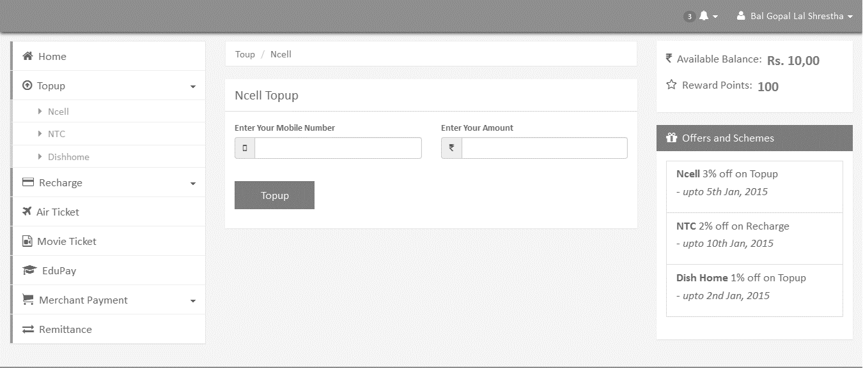

Figure 18: Screen Shot for Toup Section

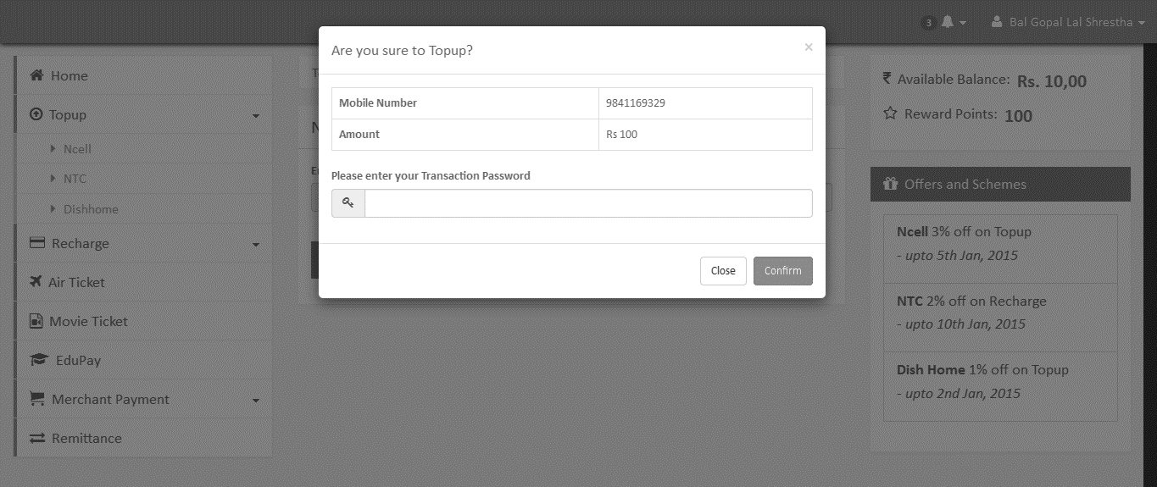

Figure 19: Screen Shot for Toup confirmation with transaction password

## Appendix B: Some Important Code Functions

**Source code of JQuery Plugin to modify HTML form component.**

//function to edit css for radio btn

$.fn.editRadioBtn=function(){

var radioBtn=$(this);

$(radioBtn).each(function(){

$(this).wrap('<span class="custom-radio"></span>');

if($(this).is(':checked')){

$(this).parent().addClass("selected");

}

});

$(radioBtn).click(function(){

if($(this).is(':checked')){

$(this).parent().addClass("selected");

}

$(radioBtn).not(this).each(function(){

$(this).parent().removeClass("selected");

});

});

}

//function to edit css for check-box

$.fn.editCheckBox=function(){

var checkBox=$(this);

$(checkBox).each(function() {

$(this).wrap("<span class='custom-checkbox'></span>");

if($(this).is(':checked')){

$(this).parent().addClass("selected");

}

});

$(checkBox).click(function(){

if($(this).is(':checked')){

$(this).parent().addClass("selected");

}

else if($(this).not(':checked')){

$(this).parent().removeClass("selected");

}

});

}

//function to edit css for dropdown list

$.fn.editSelectList=function(){

var selectList=$(this);

$(selectList).each(function(){

$(this).wrap("<span class='select-wrapper'></span>");

$(this).after("<span class='holder'></span>");

});

$(selectList).change(function(){

var selectedOption = $(this).find(":selected").text();

$(this).next(".holder").text(selectedOption);

}).trigger('change');

}

**CSS for design of HTML form component**

/*--------------- edited css for radio button ----------------------*/

.custom-radio{

width: 16px;

height: 16px;

margin-right:5px;

display: inline-block;

position: relative;

z-index: 1;

vertical-align:middle;

background: url("img/radio.png") no-repeat;

}

.custom-radio:hover{

background: url("img/radio-hover.png") no-repeat;

}

.custom-radio.selected{

background: url("img/radio-selected.png") no-repeat;

}

.custom-radio input[type="radio"]{

margin: 1px;

position: absolute;

z-index: 2;

cursor: pointer;

outline: none;

opacity: 0;

/* CSS hacks for older browsers */

_noFocusLine: expression(this.hideFocus=true);

-ms-filter: "progid:DXImageTransform.Microsoft.Alpha(Opacity=0)";

filter: alpha(opacity=0);

-khtml-opacity: 0;

-moz-opacity: 0;

}

/*--------------- edited css for checkbox ----------------------*/

.custom-checkbox{

width: 18px;

height: 19px;

margin-right:10px;

display: inline-block;

position: relative;

z-index: 1;

background: url("img/checkbox.png") no-repeat;

}

.custom-checkbox.selected{

background: url("img/checkbox-selected.png") no-repeat;

}

.custom-checkbox input[type="checkbox"]{

margin: 1px;

position: absolute;

z-index: 2;

cursor: pointer;

outline: none;

opacity: 0;

/* CSS hacks for older browsers */

_noFocusLine: expression(this.hideFocus=true);

-ms-filter: "progid:DXImageTransform.Microsoft.Alpha(Opacity=0)";

filter: alpha(opacity=0);

-khtml-opacity: 0;

-moz-opacity: 0;

}

/*--------------- edited css for dropdown list ----------------------*/

.select-wrapper{

float: left;

display: inline-block;

border: 1px solid #d8d8d8;

background: url("img/dropdown.png") no-repeat right center;

cursor: pointer;

}

.select-wrapper, .select-wrapper select{

width: 200px;

height: 26px;

line-height: 26px;

}

.select-wrapper:hover{

background: url("img/dropdown-hover.png") no-repeat right center;

border-color: #239fdb;

}

.select-wrapper .holder{

display: block;

margin: 0 35px 0 5px;

white-space: nowrap;

overflow: hidden;

cursor: pointer;

position: relative;

z-index: -1;

}

.select-wrapper select{

margin: 0;

position: absolute;

z-index: 2;

cursor: pointer;

outline: none;

opacity: 0;

/* CSS hacks for older browsers */

_noFocusLine: expression(this.hideFocus=true);

-ms-filter:"progid:DXImageTransform.Microsoft.Alpha(Opacity=0)";

filter: alpha(opacity=0);

-khtml-opacity: 0;

-moz-opacity: 0;

}

1. ­­­­ Source: CMB Consumer Pulse, spring 2013: The mobile Moment Barriers and Opportunities for mobile wallet.
2. Source: Digital wallet in depth: What are they? How do they work? And where do credit unions fit in?"
3. Source: Digital Research, Inc. "MOBILE APP & DIGITAL WALLET USAGE 2013 Consumer Research"